### Transfer Project Standards

The “Transfer Project Standards” feature facilitates the migration of settings for family types, line weights, materials, View Templates, object styles, fill patterns and similar basic project settings from one Revit file to another. This feature is beneficial for both in-house project teams and large capital projects to maintain consistency across all project documents.

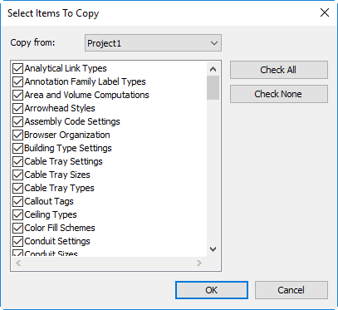

Figure 2.3‑2 Select Items

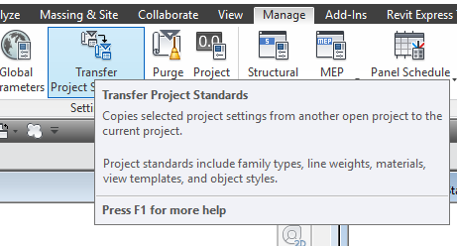

Figure 2.3‑1 Transfer Project Standards